**2.1 Classifying Monomials, Binomials and Trinomials**



**Prefixes and Roots**

**Mono**: One (monocle, monologue, monotone)

**Bi**: Two (bicycle, biplane, biannual, biathlon)

**Tri**: Three (tricycle, triangle, triptych, triathlon)

**Poly**: Many (polytheism, polytechnic, polygon)

**Nom**: Name, term (nom de plume, trigonometry)

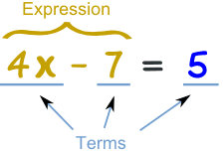

**Term**

In Algebra a **term** is either a single number or variable, or numbers and variables multiplied together. **Terms** are separated by + or − signs.

**Polynomial**

Polynomial: an expression of more than two algebraic terms, especially the sum of several terms that contain different powers of the same variable(s).

A string of terms with **exponents that are whole numbers**

We can call all groups of terms polynomials, but we have specific names for expressions with one, two or three terms.

Monomials have one term

Binomials have two terms

Trinomials have three terms

Anything more: Polynomial

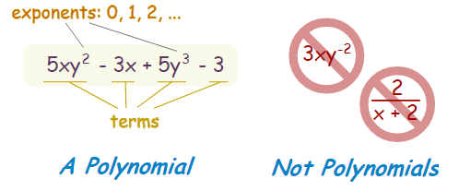

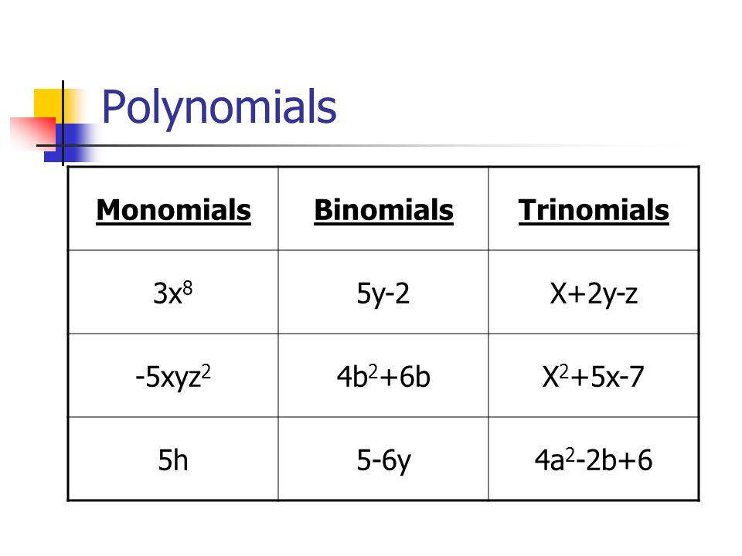

**Classifying by Degree**

We classify polynomials based upon their highest exponent. The highest exponent will tell us the degree of a polynomial.

This degree will tell us about characteristics of a graph of a polynomial function such as the number of solutions and number of changes in direction/points of inflection.

**PLEASE NOTE!!!**

1. Constants and monomials are still referred to as polynomials
2. Constants have a degree of zero because of the zero exponent rule.

$$x^{0}=1 x≠0$$

In the example below we see that 5 is listed as a zero degree polynomial.

$$5x^{0 }=5$$

