Adding Negative Numbers

**Negative Numbers**

Negative numbers are a set of numbers that are less than zero. They go on forever just like positive numbers, but in the opposite direction. Just as positive numbers go to infinity, negative numbers go to negative infinity.

Negative numbers are ALWAYS LESS THAN POSITIVE NUMBERS

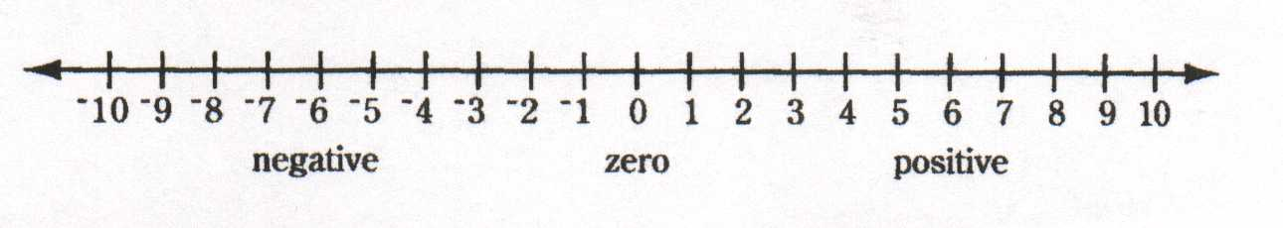

**Magnitude**

In mathematics, magnitude means the distance traveled regardless of direction.

Usually the absolute value, or distance from zero

Here we see that -10 and 10 are both a distance of 10 from zero, they have the same magnitude

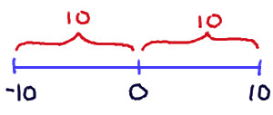

$$6+6=12$$

**Adding a positive and a positive.**

* **Add the numbers together.**
* A positive and a positive make a larger positive number.

**Adding a negative and a negative.**

* **Add the numbers and keep the negative sign**
* When you add two negative numbers you are taking a negative and making it “more negative”

$$-7+ -6= -13$$

$$-10+6= -4$$

Here (-10) has a larger magnitude so we take the negative sign.

Then we say 10 – 6 = 4

**Adding a Negative and a Positive**

* **Determine the greater magnitude to determine the sign**
* **Subtract (Larger – Smaller) based on magnitude**
* Your two numbers are pulling in opposite directions, the greater magnitude wins.

