Properties of Algebra

Algebra comes from the Arabic “al-jabr” meaning restoration. Essentially it is the moving or “transposing” of numbers and variables to balance and solve an equation.

Example

$$x-7=14$$

Using the addition property of equality, we can solve for x.

$$x-7=14$$

$$+7 +7$$

$$x=21$$

**Addition Property of Equality**

If equal quantities are added to each side of an equation, the statement stays true.

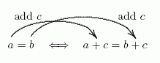

Example

$$x+7=14$$

Using the subtraction property of equality, we can solve for x.

$$x+7=14$$

$$-7 -7$$

$$x=7$$

**Subtraction Property of Equality**

If equal quantities are subtracted to from side of an equation, the statement stays true.

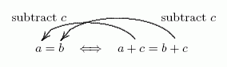

Note that this rule is actually the same, we could say you were adding negative numbers.

Example

$$\frac{x}{2}=14$$

Using the multiplication property of equality, we can solve for x

$$\left(2\right)*\frac{x}{2}=14*\left(2\right)$$

$$\frac{2x}{2}=28$$

$$x=28$$

**Multiplication Property of Equality**

If equal quantities are multiplied on each side of an equation, the statement stays true.

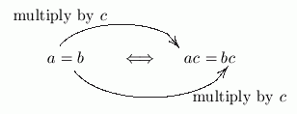

Example

$$2x=14$$

Using the division property of equality, we can solve for x

$$2x=14$$

$$\frac{2x}{2}=\frac{14}{2}$$

$$x=7$$

**Division Property of Equality**

If equal quantities are divided on each side of an equation, the statement stays true.

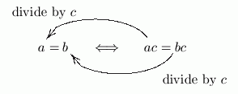

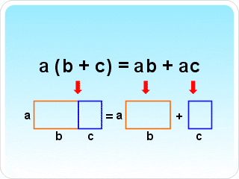

**Distributive Property of Multiplication over Addition**

Also known as the distributive property, you can multiply multiple terms inside of parenthesis by a term outside.

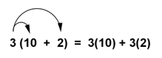

**IMPORTANT!!!**

When there is a negative sign it’s really a negative 1, you must distribute a -1

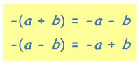

**Commutative Property**

In addition and subtraction, the order of the numbers does not matter. This also holds true for negative numbers, but the operation being performed must be addition or multiplication.

It’s commutative…like commute, like going back and forth to work.

