**Algebra 1.2 Solving Equations**

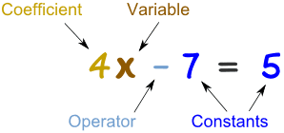

**Function: Evaluate**

$$f\left(x\right)= 4x+3$$

Functions are a relationship between two sets of numbers an input and an output. We evaluate them to observe the relation.

**Inequality: Solve**

$$4x+3 ≥7$$

Inequalities can be solved but do not have definite answers like equations, the solutions can be sets of numbers.

**Expression: Simplify**

$$4x+3x-7$$

Expressions cannot be solved, there is not equality. We put them in simplest terms so they are easy to understand

**Equation: Solve**

$$4x+3=7$$

Equations can be solved by isolating a variable. For one variable you need one equation to solve, for two variables, two equations…

+ 9 - 7 c b

Constants

Terms that remain unchanged by variables. Single numbers.

* / + - $\sqrt{x} x^{2}$

Operator

The common symbols used to show actions that need to be taken.

$\frac{1}{2}x$ $5y$ $-7m$



Coefficient

Coefficients magnify variables. Since there is no symbol between coefficient and variable we know to multiply. Remember magnifying can make things bigger or smaller.

Variable

A variable is a letter or symbol which represents a number. Usually these letters are lower case.

x y z t h Ө