**Algebra 1.3 Solving Equations**

Inverse Operations

In order to isolate variables, we use a series of inverse operations to remove all constants and coefficients.

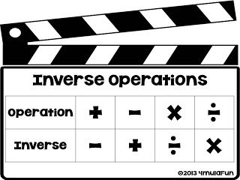

A Note on Parentheses

If a number is outside of a parentheses, ready to be distributed, it can be viewed as a coefficient.

This means we can divide the whole expression to help isolate

YOU CAN ALWAYS DISTRIBUTE AND SOLVE….BUT!

$$2\left(x+3\right)=14$$

$$\frac{2\left(x+3\right)}{2}=\frac{14}{2}$$

$$x+3=7$$

$$x=4$$

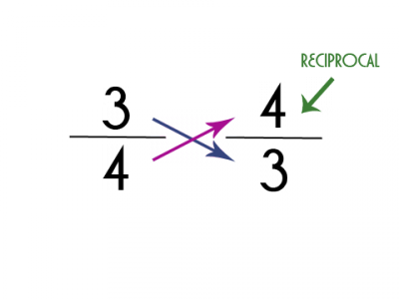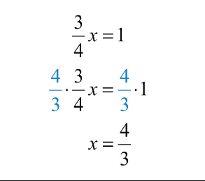

Reciprocal

The reciprocal of a number is the number that when multiplied, has a product of one.

Here $\frac{4}{3}$ is the reciprocal of $\frac{3}{4}$ because when we multiply the two fractions we get…

$$\frac{3}{4}*\frac{4}{3}=\frac{12}{12}=1$$

Because of the commutative property, $\frac{3}{4}$ is also the reciprocal of $\frac{4}{3}$.

Almost all Algebra Equations have the same end goal. To isolate a variable.

Isolating a variable gives us a clear indication of the solution to an equation

$$x=5$$

Tips for Two Step Equations

1. Simplify equations using other properties of algebra.
2. Whenever possible, perform addition and subtraction properties first. Usually there are no variables or coefficients, so you will just be moving numbers.
3. Perform operations with multiplication, division and reciprocals last, this will save you from having to perform the distributive property.