Algebra I 1.4 Isolating Variables in Equations with Multiple Variables

Variable
  - A letter or symbol which represents an unknown value in an expression.
$$y=mx+b$$

Ratio
  - The indicated quotient of two mathematical expressions. A ratio shows the relative sizes of two or more values. This is the ratio for pi, circumference vs diameter.

Formula
  - A mathematical relationship or rule expressed in symbols. This formula is for density, a ratio of mass to volume.

$$d=\frac{m}{v}$$

$$π=\frac{c}{d}$$
“In Terms of”
If we are given one equation, we can solve for one variable.
Sometimes, formulas and equations have multiple variables. Even though we cannot definitively solve them, we can put variables “in terms of” other variables.
In our 3 equations
$y=mx+b$ “y is solved for in terms of m, x and b”
$d=\frac{m}{v}$ “d is solved for in terms of m and v
$π=\frac{c}{d}$ “π is solved for in terms of c and d”
When we are asked to solve for a variable “in terms” of another, our answer will have a highlighted variable.
Solve for x in terms of y m and b
$$y=mx+b$$
$$y-b=mx$$
$$\frac{y-b}{m}=x$$
$$x=\frac{y-b}{m}$$
Solve for m in terms of d and v
$$d=\frac{m}{v}$$
$$dv=m$$
$$m=vd$$
Solve for c in terms of π and d
$$π=\frac{c}{d}$$
$$πd=c$$
$$c=πd$$

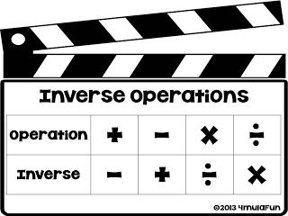
Variables
y m x b

d m v

c d

