Axis of Symmetry/Vertex Notes

$$f\left(x\right)=ax^{2}+ bx+c a≠0$$

$$y=ax^{2}+ bx+c a≠0$$

a: Determines width of a graph and which way the parabola opens

b: Influences the location of the vertex

c: Influences the y intercept

**Axis of Symmetry**

As with linear functions an “x =” graph is a vertical line.

The axis of symmetry is the reflecting line.

Found using the equation

$$x= \frac{-b}{2a}$$

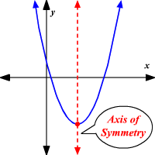

**Vertex**

The vertex is an (x,y) point that tells us when a parabola changes direction.

It is a maximum or minimum value.

It can be found by evaluating a quadratic function with the x value found for the axis of symmetry

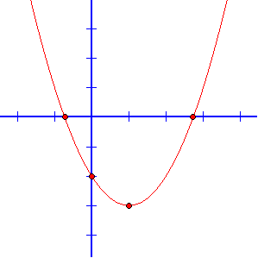

Given the function equation of a function y $= x^{2}-4x+8$ find the vertex

1. Identify a, b, c **a = 1 b = -4 c = 8**
2. Find the axis of symmetry $x=\frac{-b}{2a}$ $x=\frac{-(4)}{2(1)}=\frac{4}{2}$**= 2**
3. Plug x into the original equation/function $y= {\left(2\right)}^{2}-4\left(2\right)+ 8$

$y= 4$

1. Express your answer in (x,y) form **(2,4)**