Basic Probability
General Probability Fraction:
$$P\left(Event\right)= \frac{Desired Outcomes}{Total Outcomes}$$

Union Symbol Intersection Symbol
“or” “and”

Equations
Mutually Exclusive (Cannot happen at the same time)
P(A ∪ B) = P(A) + P(B)

Mutually Inclusive (Can happen at the same time)
P(A ∪ B) = P(A) + P(B) − P(A ∩ B)

Notes
Coin Toss

Two sides, heads and tails
Equal odds
Can easily be drawn as a factor tree to find out results

$$Type equation here.$$

Coin Toss

Two sides, heads and tails
Equal odds
Can easily be drawn as a factor tree to find out results
Coin Toss

Two sides, heads and tails
Equal odds
Can easily be drawn as a factor tree to find out results
Coin Toss

Two sides, heads and tails
Equal odds
Can easily be drawn as a factor tree to find out results

Compound Events: Independent vs Dependent Events
Compound Events
Multiple events that are connected to find combined probability
For compound events we always multiply fractions.

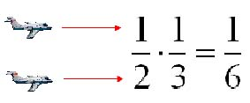
Independent Events
Compound events where the outcome of events have no impact on each other.
Common Examples are dice and coins and picking from a group WITH REPLACEMENT
P(A and B) = P(A) * P(B)

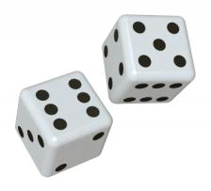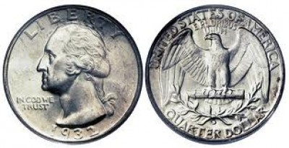

Dependent Events
Compound events where the outcome of events influence each other.
Almost always from a group WITHOUT REPLACEMENT
P(A and B) = P(A) * P(B|A)

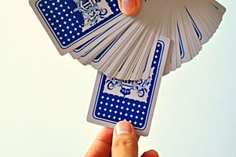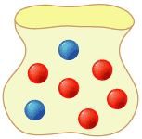
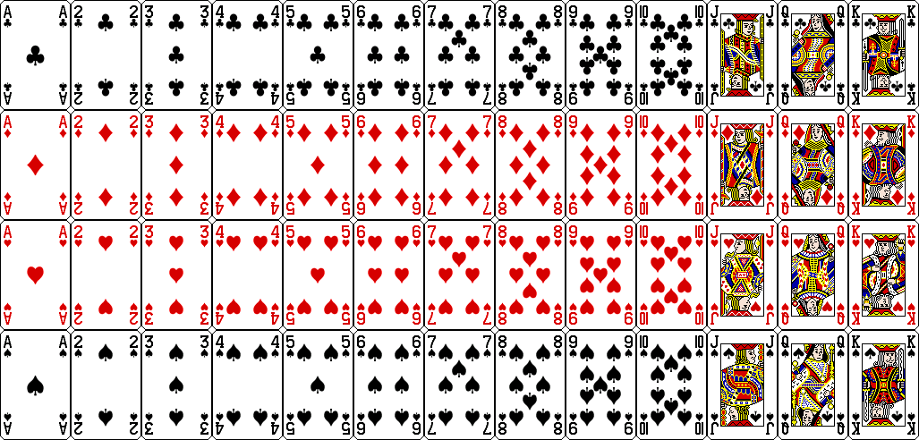
Quick Facts
52 Total Cards
26 Red, 26 Black
4 Suits: Clubs, Diamonds, Hearts and Spades
13 Cards in each suit
3 Face cards Jack, Queen, King in each suit, 12 total

