**Basic Right Angle Trigonometry Notes**

Trigonometry is based around ratios found in right triangles.

Since the right angle takes half of the 180 degrees, there is only 90 degrees left for the other two angles (complimentary)

If one angle gets bigger, the other gets smaller.

Remember the larger an angle, the longer the side across.

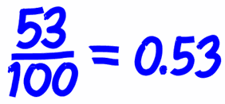

**Theta**

Theta is a variable used for angles in trigonometry.

It is a Greek letter and represents an unknown angle.

We use it as a reference point for our ratios.

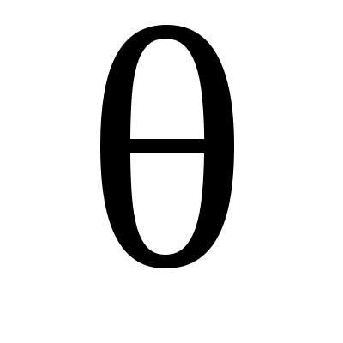

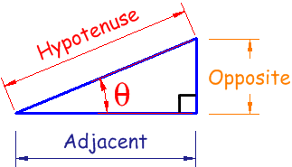

**The Three Sides**

**Opposite: The side across from your angle, here the orange side is opposite our reference angle theta.**

**Adjacent: Next to, the adjacent side is purple. Note there are two adjacent sides that make up theta. The one we refer to as adjacent is not the hypotenuse.**

**Hypotenuse: The hypotenuse is the longest side of a right triangle located across from the right angle. While adjacent and opposite change depending on the location of theta, the hypotenuse has a definite location and never changes.**

**The Ratios: Sine, Cosine and Tangent**



**How to Remember Them:**

