**Circle Notes**

A **circle** is a two dimensional shape with all points on the circle being an equal distance from a single point: the **center**.

All circles are **similar** (~) meaning that they have the exact same shape but are different sizes. Because of this fact all circles can be **mapped** to one another using only two rigid motions, a **dilation** and a **translation**

**Basic Circle Vocabulary**

**Radius**: The constant distance from the center to a point on the circle.

$$r=\frac{d}{2}$$

**Diameter**: A line from one point on a circle to another which goes through the center

$$d=2r$$

**Chord**: A line from one point to another on a circle. The diameter is the longest chord.

**Tangent**: A line outside of the circle which touches the circle exactly one time. It creates A right angle with a radius or diameter.

**Secant**: A line outside the circle which intersects with the circle twice.

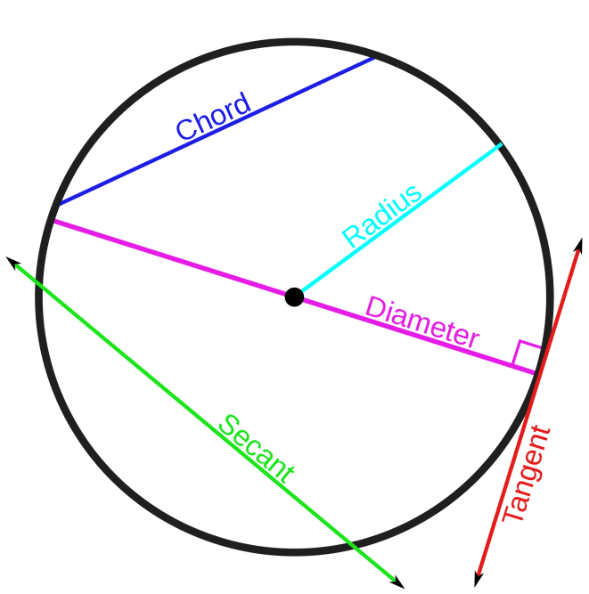

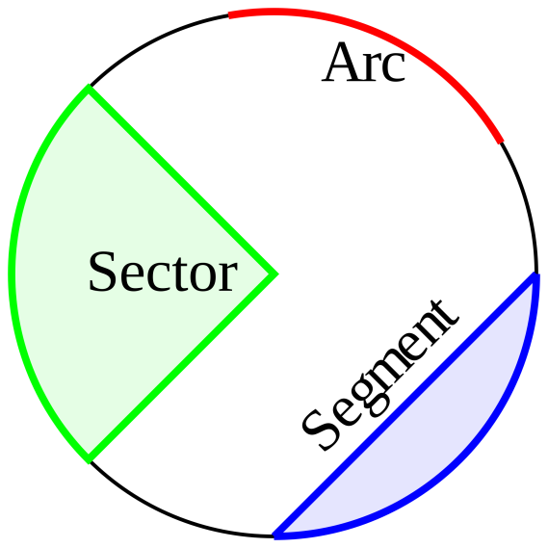

**New Terms**

**Arc**: The distance around part of the circle. It can be measured as a distance or a degree measure out of 360

**Sector**: An area of a circle bound by an arc and two radii

**Segment**: An area of a circle bound by a chord and an arc

Arcs and Angles

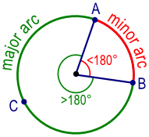

All of the arcs of a circle combine to make 360 degrees.

**Minor Arcs** are those with measurements less than 180 degrees.

**Major Arcs** are those with measurements greater than 180

**Semicircles** are exactly 180 degrees in measure.

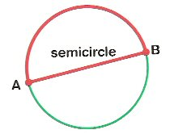

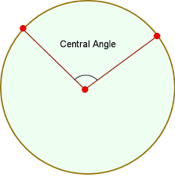

A **central angle** is an angle created by two radii.

Because there are 360 degrees in a central angle, and 360 degrees of arc measure.

$$degrees of central angle=degrees of arc$$

Knowing a major arc means we also know the minor arc

$$360-major arc=minor arc$$

$$360-minor arc=major arc$$

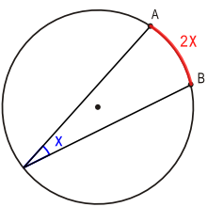

An **inscribed angle** is an angle drawn on the outside of the circle, through the circle with two chords

The degree measure of an inscribed angle is half the arc length

$$Inscribed angle= \frac{1}{2} arc$$

$$arc=2*inscribed angle$$