Name:________________________
Flipping Coins:
- P( H and H) Probability of obtaining two heads in a row

- P (Tails and Tails) Probability of obtaining two tails in a row

- P (Heads, Heads, Heads, Heads) Probability of four heads in row

Rolling Dice
- P( 5 and 6 ) Probability of rolling a five and a six consecutively

- P (Odd and Odd) Probability of rolling two odd numbers

- P(5, 5, 5) Probability of rolling a 5, three times in a row

- Bag A contains 9 red marbles and 3 green marbles. Bag B contains 9 black marbles and 6 orange marbles. Find the probability of selecting one green marble from bag A and one black marble from bag B.

- If you draw two cards from a standard deck of 52 cards without replacement, find:
  - P(King first, Jack second)

  - P(face card first, ace second)

  - P(2 aces)

- A box contains 5 purple marbles, 3 green marbles and 2 orange marbles. Two consecutive draws are made from the box without replacement of the first draw. Find the probability of each event.
  - P(orange first, green second)

  - P(both marbles are purple)

  - P(the first marble is purple, and the second is ANY color EXCEPT purple)

Bonus Question
In a bag there are 2 red marbles, 3 white marbles and 5 blue marbles. Once a marble is selected, it IS replaced. Find the following probabilities:

a. P(white, blue)

_______________________

b. P(white, white)

_______________________

c. P(blue, white, red)

_______________________

d. P(blue, blue, blue)

_______________________

Probability Notes
Multiplying Fractions
$\frac{1}{2} * \frac{5}{8} = \frac{5}{16}$

When multiplying fractions,
- Multiply the numerators
- Multiply the denominators,
- Reduce if needed

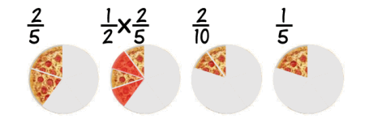

Independent Events
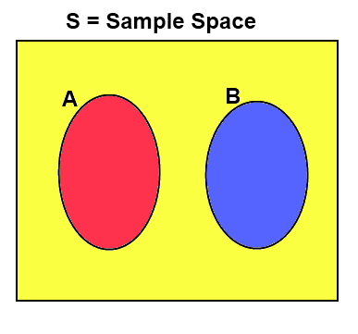
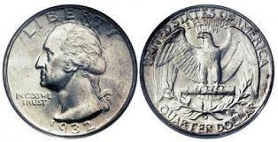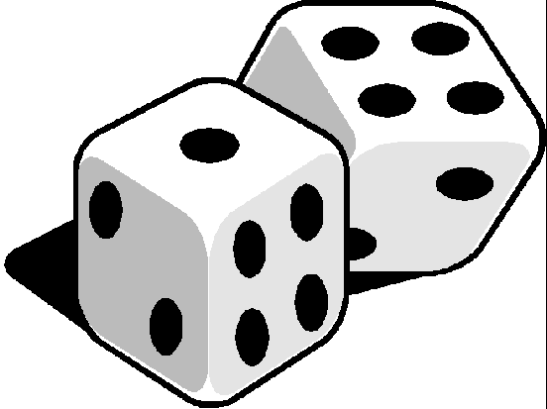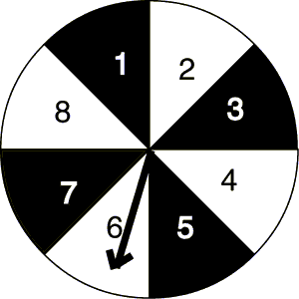
“With Replacement” “Is replaced”

Dependent Events
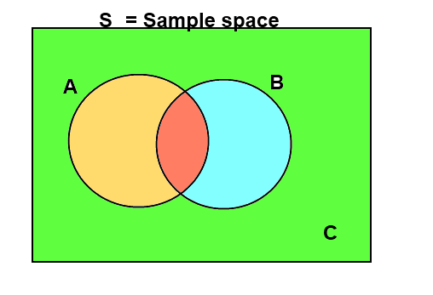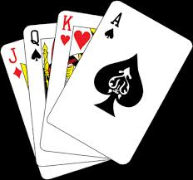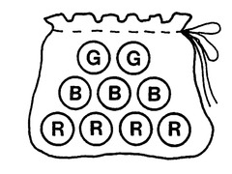
“Without replacement” “Is not replaced”

