**Equation of a Circle Notes**

A **circle** is a two dimensional shape with all points located an equal distance from the **center**. We call the distance from the center to any point on the circle the **radius**.

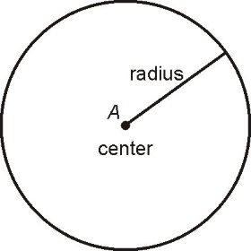

**The Distance Formula**

When performing geometry on a coordinate plane, we can modify the Pythagorean Theorem to find the distance between two points.

We can use horizontal distance $\left(x_{2}-x_{1}\right)$ and vertical distance $\left(y_{2}-y_{1}\right)$ as the legs of a right triangle and the distance between two points as the hypotenuse.

$$a^{2}+b^{2}=c^{2}→{\left(x_{2}-x_{1}\right)}^{2}+{\left(y_{2}-y_{1}\right)}^{2}=d^{2}$$

Usually we rewrite the distance formula highlighting d by taking the square root and placing at the front of the equation.

$$d=\sqrt{{\left(x_{2}-x_{1}\right)}^{2}+{\left(y_{2}-y_{1}\right)}^{2}}$$

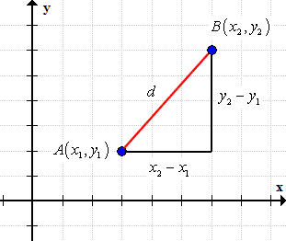

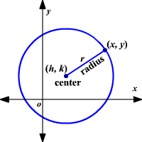

The equation of a circle is a modified version of the **distance formula**

Since the distance from center to any point on the circle is equal, we can use the distance formula to create an equation.

$${\left(x_{2}-x_{1}\right)}^{2}+{\left(y_{2}-y_{1}\right)}^{2}=d^{2}$$

Rewrite with the center defined as the point (h,k) and any point on the circle as (x, y)

$${\left(x-h\right)}^{2}+{\left(y-k\right)}^{2}=r^{2}$$

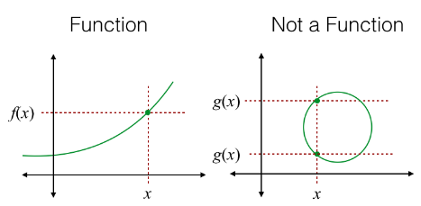

It is important to note that this is an **equation** and a **relation** but **not a** **function** as a circle fails the **vertical line test**.

If we solve for y, we would find…

$$y=\sqrt{r^{2}-{(x-h)}^{2}}+k$$

The square root gives positive and negative answers, so a circle is not a function, if graphed as a function we get a semicircle.

