**Expressing Domain and Range**

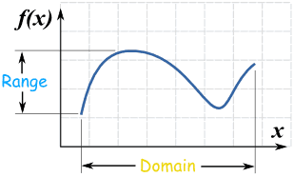

Domain and Range

The domain and range of a function essentially tell us where the function is defined.

The domain gives us the x values that obtain a real answer to the function

The range gives us the y or f(x) values that can be obtained from evaluation.

Inequality Notation

In grade school, you used these symbols to show numbers which were greater and less than other numbers.

Now we will use them to let us know what x and y values are defined.

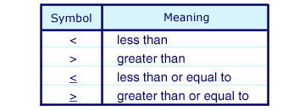

Number Line Inequalities

Here we represented inequalities graphically in one dimension.

When defining domain and range we can use the same strategy.

Label on the x axis and y axis where values are defined and write appropriately.

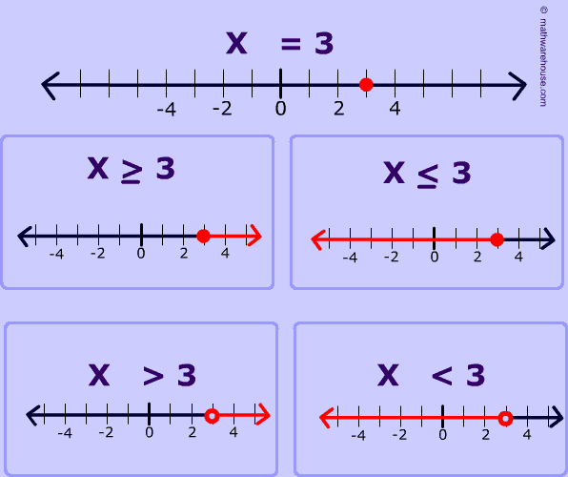

Number Sets

There are defined sets of numbers that we use and that you may see.

Unless otherwise implied we are looking at Reals

If you were talking about a specific set you would write…

$$\left\{x∈R \right| x ≠5\}$$

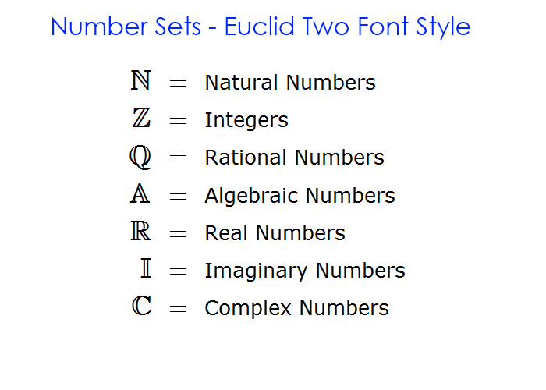

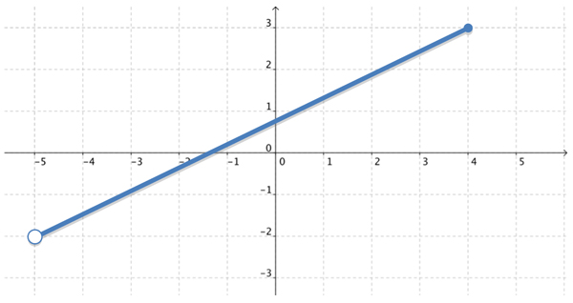

**Set Builder Notation**

For Domain:

1. Observe the graph of the function and determine what x values have answers defined.
2. Write the open set
$$\left\{x \right| x \}$$

3. Determine whether greater/less than or equal to signs should be used
$$\left\{x \right| <x≤ \}$$

4. Place your minimum and maximum values

$$\left\{x \right| -5 <x≤4 \}$$

For Range:

1. Observe the graph of the function and determine what y values are defined defined.
2. Write the open set
$$\left\{y \right| y \}$$

3. Determine whether greater/less than or equal to signs should be used
$$\left\{y \right| <y≤ \}$$

4. Place your minimum and maximum values

$$\left\{y \right| -2 <y≤3 \}$$

Interval Notation

Soft brackets () mean that numbers are not included

$$<or>$$

Hard brackets [] mean that the number is included

$$≤or≥$$

For above

Domain: (-5,4]

Range: (-2, 3]

