**Finding Asymptotes and Holes**

Asymptote

a line that continually approaches a given curve but does not meet it at any finite distance.

It moves infinitely closer to line but never actually gets there.

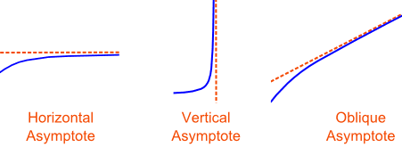

Vertical Asymptotes

Vertical Asymptotes occur where rational functions are undefined. There is no output because an input creates a zero denominator.

To find vertical asymptotes, set the denominator equal to zero.

$$f\left(x\right)=\frac{-4}{x^{2}-3x}$$

$$x^{2}-3x=0$$

$$x\left(x-3\right)=0$$

$$x=0 x=3$$

Remember lines that feature the form x= are vertical

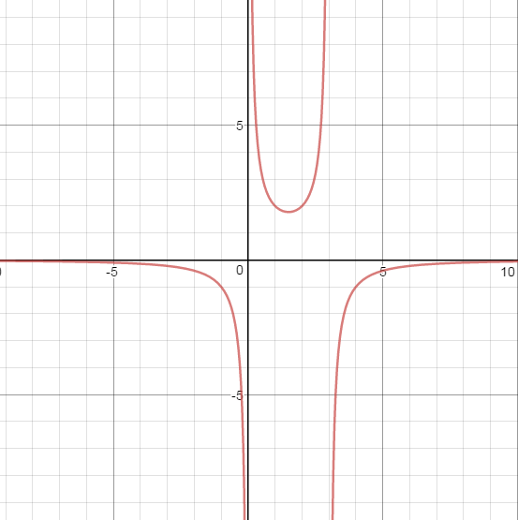

Horizontal Asymptotes

There are three situations, based about the highest exponents in the numerator and denominator

$$f\left(x\right)= \frac{{ax}^{m}}{bx^{n}}$$

1. If n < m the x-axis is the horizontal asymptote
2. If n = m then the horizontal asymptote is located at $y=\frac{a}{b}$
3. If n > m then there is no horizontal asymptote. The asymptote will be slant or oblique

Holes

Holes occur when there is a common polynomial factor in numerator and denominator. Although the factors “cancel” we cannot ignore the number that makes the factor equal to zero.

$$f\left(x\right)=\frac{x^{2}(x-2)}{x-2}$$

