Geometry 1.2 Basic Relationships Among Points, Lines and Planes

Definition: assigns meaning to a word using previously defined words. Definitions provide only the minimum information needed, properties that can be proven using the definition are not included.

* A triangle is a polygon with three sides.

Postulate/Axiom: A statement accepted to be true, but that cannot be proved.

* Exactly one straight line may be drawn through two points.

Theorem: a statement that can be proven to be true using logical argument.

* The diagonals of a square are perpendicular.

Congruence Markings $≅$

We show congruence on diagrams using a system of mark lines.

If the same number of marks occur on different sides or angles they are congruent and equal in measure.

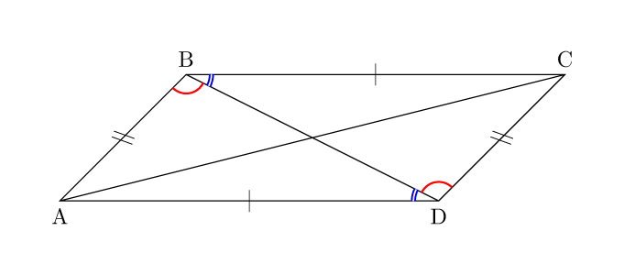

Colinear: on the same line

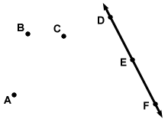 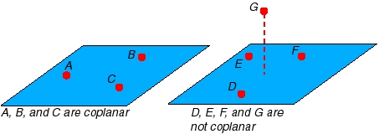

Coplanar: on the same plane

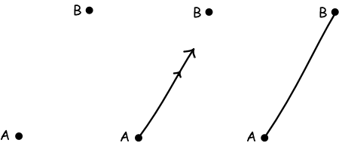

**Postulate #1**

There is one and only one line that connects two points.

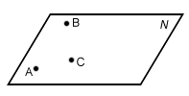

**Postulate #2**

There is one, and only one plane that contains three given points.

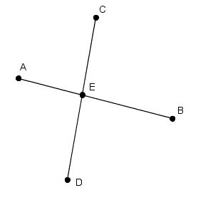

**Postulate #3**

The intersection of two lines is a point.

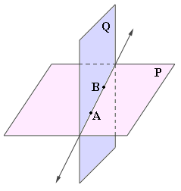

**Postulate #4**

The intersection of two planes is a line.

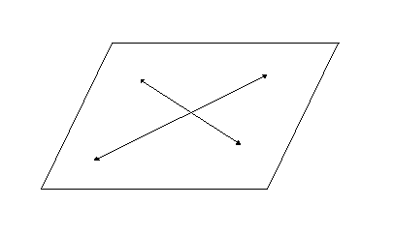

**Postulate #5**

Intersecting lines are always coplanar.

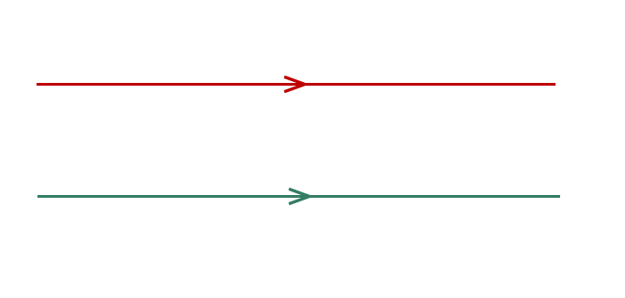

Parallel

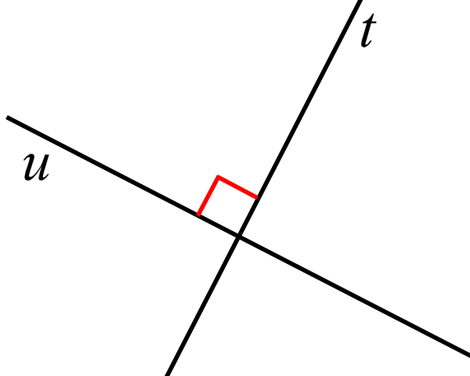

Perpendicular

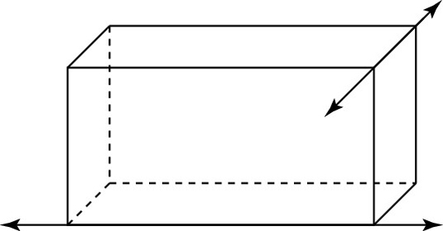

Skew