Geometry 1.3a: Review of Algebra Skills

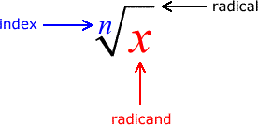

**Radicals are symbols for taking the “root” of a number.**

The most common radical is the “square root” which tells us a number which when multiplied by itself makes the radicand.

The index tells you what root is being found, how many times a number will be multiplied by itself to create the radicand.

The radicand is the number that is having its root taken.

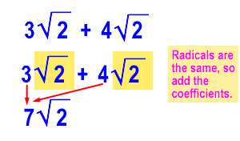

To add or subtract in radical expressions, the terms must have the same index and radicand. Add or subtract the coefficients and keep the radicals.

Essentially, treat the radicals as if they were variables.

To multiply: Multiply coefficients and multiply radicands separately.

You can do this because of the commutative property. Remember to simplify if needed.

$$2\sqrt{3}*4\sqrt{5}=8\sqrt{15}$$

OR! Commutative

$$2\sqrt{3}*4\sqrt{5}=2*4*\sqrt{3}*\sqrt{5}=8\sqrt{15}$$

To divide: Divide coefficients and divide radicands separately.

Also note that the radical can be placed over each individual radicand or over both as a fraction.

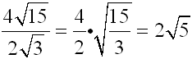

**Simplest Radical Form**

Many radicals when evaluated create irrational numbers, by keeping them in radical form we get a more accurate answer.

To put in simplest form, you must look for factors of the radicand which can be evaluated as integers.

Like finding common factors for fractions, finding common radicands will help us add and subtract

BE CAREFUL, SOMETIMES WE CAN MISS IMPORTANT FACTORS

Here, $3\sqrt{8}$ is not in simplest radical form

$$\sqrt{72}$$

$$\sqrt{36}*\sqrt{2}$$

$$6\sqrt{2}$$

$$\sqrt{72}$$

$$\sqrt{9}*\sqrt{8}$$

$$3\sqrt{8}$$

3 $\sqrt{4}*\sqrt{2}$



$$3*2*\sqrt{2}=6\sqrt{2}$$

*

Inverse Operations

Remember that squares and square roots are inverse operations

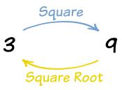

$$\sqrt{x}= \sqrt{x}$$

$$\sqrt{x^{2}}=x$$

$$\sqrt{x^{3}}=x* x^{2}=x\sqrt{x}$$

$$\sqrt{x^{4}}=x^{2}$$

Dealing with Variables with Exponents

Because exponents and roots are inverse operations, they can undo each other….

Essentially, divide the exponent by the root. Any remainder will still be the radicand.

Why Geometry?

Square roots are very useful in finding one dimensional distances when given two dimensional area. The same can be said for cube roots and volume.

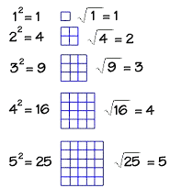

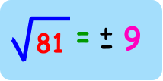

What About the Negatives?

Since we are usually concerned with distances in geometry, we can often reject the negative answer and only utilize the principal square root

The Future (Algebra II)

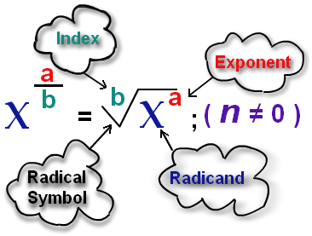

Radicals can also be written as a fractional exponent, which explains some of their properties.

$$\sqrt{x^{2}}=x$$

$${(x^{2})}^{\frac{1}{2}}=x^{\frac{2}{2}}=x$$

