**Geometry 2.4: Parallel Lines**

**Transversal**

A transversal is a line or segment that crosses over two or more other lines or segments.

If the lines are parallel, the transversal creates identical intersections

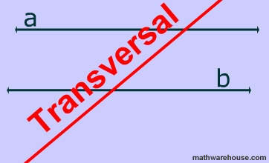

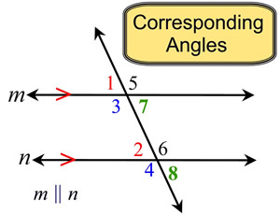

**Corresponding Angle Postulate**

Two lines intersected by a transversal are parallel if and only if the corresponding angles are congruent.

If the angles match, the lines are parallel

If the lines are parallel, the angles match.

**Alternate Interior Angle Theorem**

Two lines intersected by a transversal are parallel if and only if the alternate interior angles are congruent.

Interior means inside, alternate means back and forth, so alternate interior angles are on the inside of the parallel lines on opposite sides of the transversal.

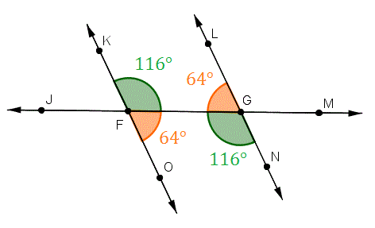

**Same Side Interior Angle Theorem**

Two lines intersected by a transversal are parallel if and only if the same side interior angles are supplementary.

Supplementary means to add up to 180 degrees.

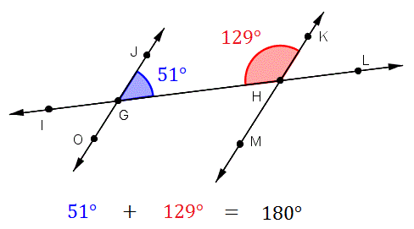

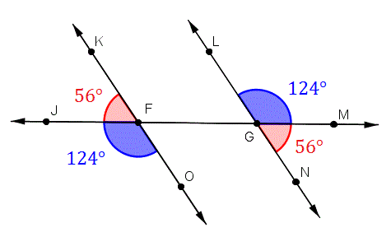

**Alternate Exterior Angle Theorem**

Two lines intersected by a transversal are parallel if and only if the alternate exterior angles are congruent.

Exterior angles are those on the outside of the parallel lines.