**Graphing Proportional Relationships**

**Characteristics of Proportional Graphs**

#1 They must be a straight line.

#2 They must pass through the origin, the point (0, 0)

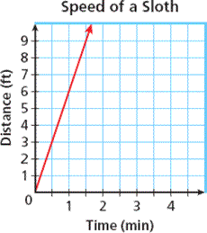

**Choosing Independent and Dependent Variables**

Input: Your x value, the independent variable is the cause.

Output: Your y value, the dependent variable is the effect.

Use your rate, remember $a=\frac{y}{x}$

Tip: Look for time, remember, seconds, minutes, hours, days, years, etc are all excellent x values.

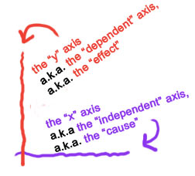

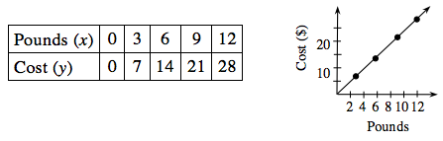

**Graphing From a Table**

1. Determine which values are independent (x) and which values are dependent (y).
2. Label your x and y axis appropriately.
3. Choose a scale.
4. Graph your points.
5. Connect the dots and label.

**Graphing from an Equation**

1. Create a chart.
2. Label your x and y axis appropriately.
3. Choose a scale.
4. Graph your points.
5. Connect the dots and label.

|  |  |  |
| --- | --- | --- |
| x | $$y=\frac{2}{3}x$$ | y |
| 0 | $$y=\frac{2}{3}(0)$$ | 0 |
| 1 | $$y=\frac{2}{3}(1)$$ | $$\frac{2}{3}$$ |
| 2 | $$y=\frac{2}{3}(2)$$ | $$\frac{4}{3}$$ |
| 3 | $$y=\frac{2}{3}(3)$$ | 2 |