Name:______________________________
f(x) = x² – 2x – 3
a:______________ b:________________ c:________________

Axis of symmetry: $x=\frac{-b}{2a}$

Vertex:

x | -2 | -1 | 0 | 1 | 2 | 3 | 4
f(x)

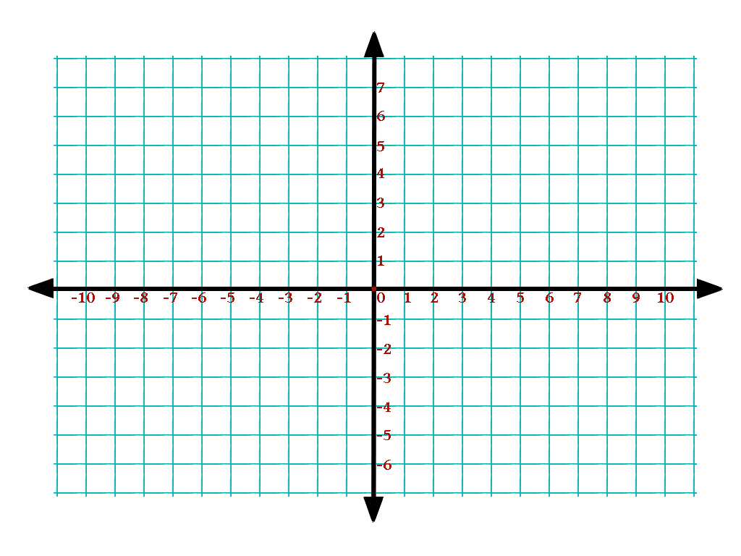

f(x) = x² + 4x
a:______________ b:________________ c:________________

Axis of symmetry: $Type equation here.$

Vertex:

x | -5 | -4 | -3 | -2 | -1 | 0 | 1
f(x)

f(x) = x² + 2x - 7

Axis of symmetry: $Type equation here.$

Vertex:

x | -5 | -4 | -3 | -2 | -1 | 0 | 1
f(x)

f(x) = x² + 6x + 1

Axis of symmetry: $Type equation here.$

Vertex:

x |  |  |  | -3
f(x)

f(x) = x² - 5

Axis of symmetry: $Type equation here.$

Vertex:

x
f(x)

f(x) = 2x² – 4x - 5

x
f(x)

