Response Sheet: Vertex
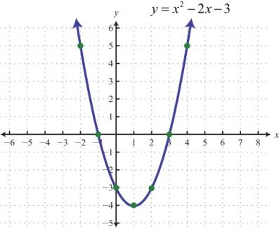 Minimum
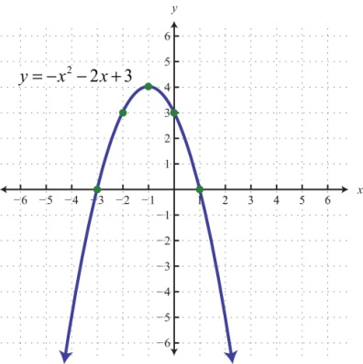 Maximum
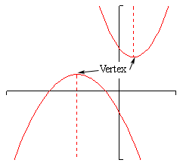 Vertex
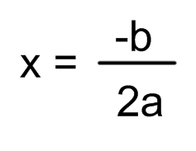 Vertex formula
Name:_________________________________
Determine the vertex and graph the function appropriately.
y = x² – 4x + 3
a =
b =
c =
x = -b
2a
x | y = x² – 4x + 3 | y | (x,y)
y = -2x² + 12x - 1
a =
b =
c =
x = -b
2a
x | y = -2x² + 12x - 1 | y | (x,y)

1 What is the turning point, or vertex, of the parabola whose equation is
y = 3x2 +6x −1?

1) (1,8)
2) (−1,−4)
3) (−3,8)
4) (3,44)

2 What are the coordinates of the turning point of the parabola whose equation is y = −x2 +4x +1?

1) (−2,−11)
2) (−2,−3)
3) (2,5)
4) (2,13)

3 What is the minimum point of the graph of the equation y = 2x2 +8x +9?

1) (2,33)
2) (2,17)
3) (−2,−15)
4) (−2,1)

