**Geometry 1.1: The Building Blocks of Geometry**

**Point**

A point in mathematics is a location, it has no associated size, length, height, width, weight etc. **Points are denoted by a single uppercase letter.**

It is just a place marked with a letter, the mark may have a mass or size, but the point it is representing is strictly a location.

A point is known as a “primitive notion” meaning an idea that does not have a proof, it is accepted as its definition. The point is the fundamental building block of geometry.

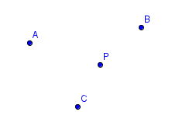

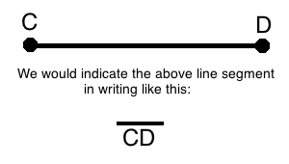 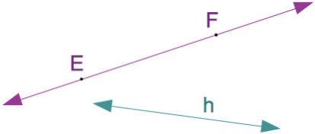 Image result for ray math

**Line Segment**

The part of a **line** that connects two points. It has definite end points. Line segments are denoted by the two endpoints with a small line segment over the top.

$$\overline{CD}$$

**Line**

A **line** is a straight one-dimensional figure having no thickness and extending infinitely in both directions. Lines are denoted by two points and a line over the top or sometimes by a single lower case letter.

$$\overset{↔}{AB}$$

**Ray**

A **ray** starts at a given point and goes off in a certain direction forever, to infinity. The point where the **ray** starts is called (confusingly) the endpoint.

$$\vec{AB}$$

**Plane**

In **mathematics**, a **plane** is a flat, two-dimensional surface that extends infinitely far.

Planes can be named with 3 non collinear points, points not on the same line.

This is plane LMN or plane P

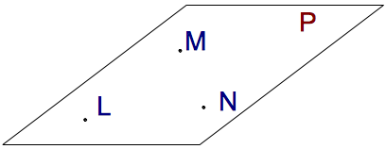

**Intersections**

Two lines intersect at a point.

Two planes intersect at a line.

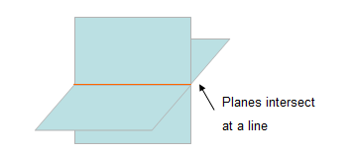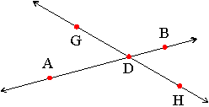

**Types of Angles**

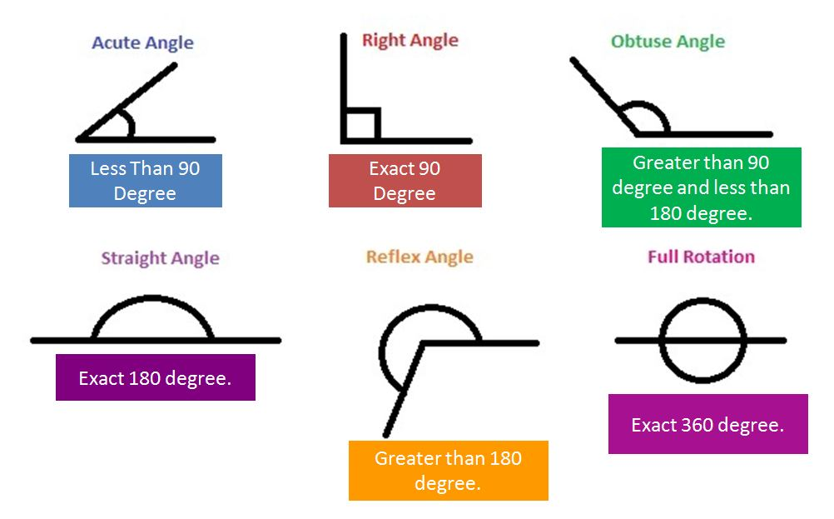

**Types of Triangles**

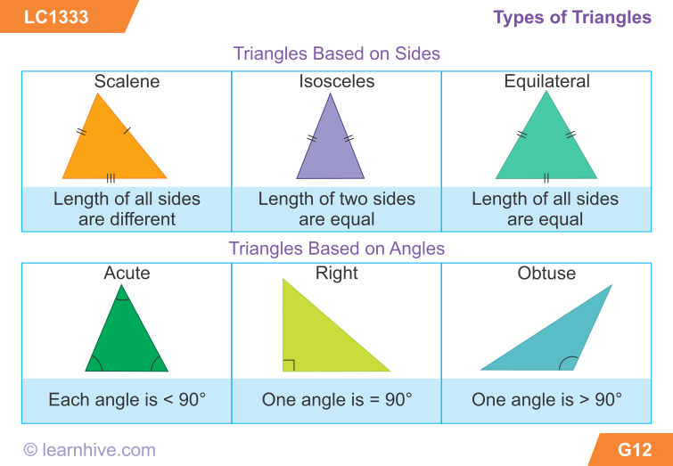

**Types of Polygons**

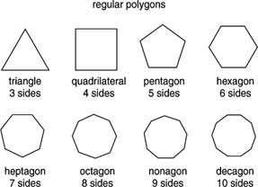

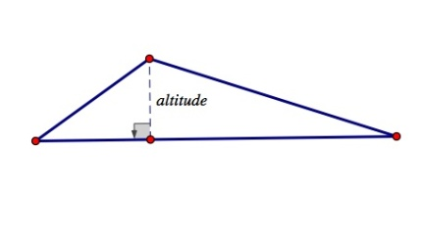

**Altitude**

In general English altitude means height.

In geometry it is a line at right angles to a side that goes through the opposite corner.

Every triangle has three altitudes, they are sometimes found outside of the triangle.

You need altitude for certain equations.

**Median**

A line segment from a vertex (corner point) to the midpoint of the opposite side.  
  
A triangle has three medians, and they all cross over at a special point called the "centroid"

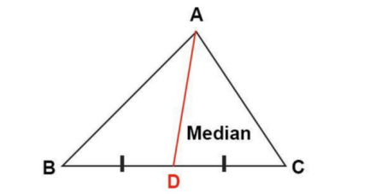

**Angle Bisector**

An angle bisector is a line or ray that divides an angle into two congruent angles.

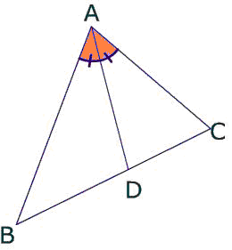

**Perpendicular Bisector**

The perpendicular bisector of a side of a triangle is a line segment that is both perpendicular to a side of a triangle and passes through its midpoint.

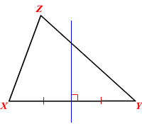

**Triangle Centers**

