Parallel and Perpendicular Systems

System of Equations

Two or more equations, when graphed the intersection is the point which makes both equations true.

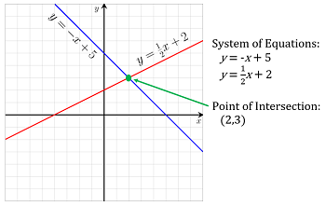

Parallel Lines

When lines are parallel, they have the same slope. They never intersect and have no common solution.

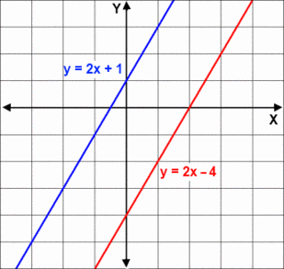

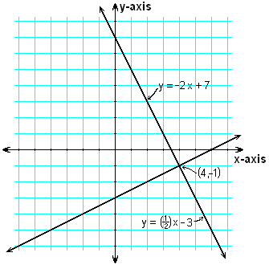

Perpendicular

Perpendicular lines intersect and make a right angle (square, 90 degrees). Their slopes are ***negative reciprocals*** of each other.

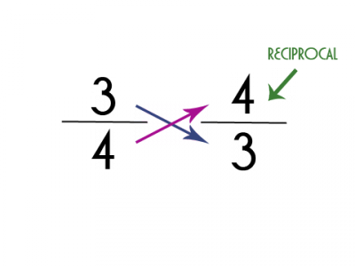

Reciprocal

The flipped version of a number. Reciprocal numbers multiply to make 1.

