**Properties of Parallelograms**

A parallelogram is a quadrilateral with two sets of parallel sides

The angles still all sum to 360 degrees.

<http://www.mathopenref.com/coordparallelogram.html>

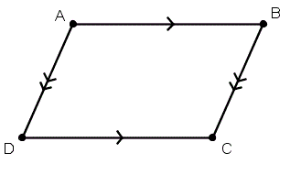

**Area = b*h**

[**http://www.mathopenref.com/parallelogramarea.html**](http://www.mathopenref.com/parallelogramarea.html)

**Area = a*b*sin C**

[**http://www.mathopenref.com/parallelogramarea.html**](http://www.mathopenref.com/parallelogramarea.html)

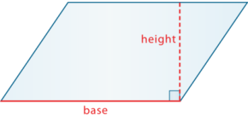

**Opposite Sides are Congruent**

<http://www.mathopenref.com/parallelogram.html>

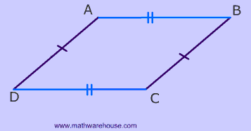

**Opposite Angles are Congruent**

<http://www.mathopenref.com/parallelogramangles.html>

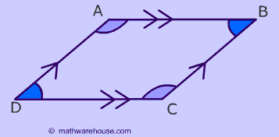

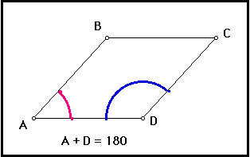

**Diagonals Bisect Each Other**

<http://www.mathopenref.com/parallelogramdiags.html>

**Consecutive Angles are Supplementary**

<http://www.mathopenref.com/anglestransinterior.html>

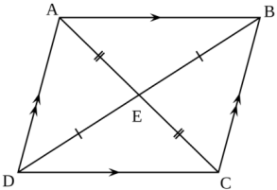

**Diagonals Create Congruent Angles (Alternate Interior Angles)**

<http://www.mathopenref.com/transversal.html>

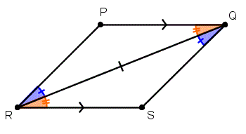

**Rhombus**

A rhombus is a parallelogram with all sides equal. In addition to all of the rules mentioned above, diagonals create right angles.

Squares are rhombi (rhombuses)

<http://www.mathopenref.com/rhombusdiagonals.html>

