Graphing Quadratic Functions
Step 1:
Make sure function is in standard form
f(x) = ax² + bx + c a ≠ 0
$$f\left(x\right)=x^{2}-2x-3$$

$x= \frac{-\left(-2\right)}{2\left(1\right)}= \frac{2}{2}= 1$
Step 2:
Determine the axis of symmetry using…
$$x= \frac{-b}{2a}$$
Evaluate the function at the line of symmetry to find the vertex

$$f\left(1\right)=(1)^{2}- 2\left(1\right)- 3$$
$$f\left(1\right)= -4$$
(1,-4)
Step 3:
Create a chart of AT LEAST 7 x values, place your line of symmetry in the center

Evaluate the function to determine the f(x) values. You can also use the table function on your calculator to obtain these points
Depending on the size of the plane being used you may need more points

x  Step 6:  Plot your points on a coordinate plane, adjust your scale accordingly if needed. | -2 | -1 | 0 | 1 | 2 | 3 | 4
f(x) | 5 | 0 | -3 | -4 | -3 | 0 | 5

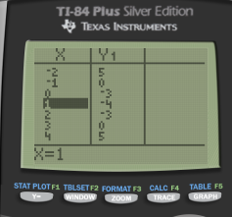
Step 4:
Plot your points on a coordinate plane, adjust your scale accordingly if needed.
