Reference Triangles
Reference Triangles are right triangles which contain “important” angles. They can be moved around the unit circle to tell us locations. Eventually they will help us with trigonometric functions.

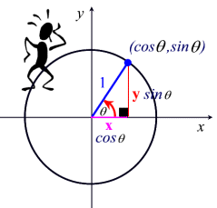
To find any coordinate on the unit circle, we can evaluate the angle of rotation. Make sure you use radians/degrees accordingly.
$$\left(x,y\right)→(cosθ,sinθ)$$
Degrees | Radians | Degrees | Radians
$\sin{30}$ = .5 | $$\sin{\frac{π}{6}=.5}$$ | $\cos{30}$ = .8660… | $$\cos{\frac{π}{6}=.8660…}$$
$\sin{45}$ = .7071… | $$\sin{\frac{π}{4}}=.7071…$$ | $\cos{45}$ = .7071… | $$\cos{\frac{π}{4}=.7071}…$$
$\sin{60}$ = .8660… | $$\sin{\frac{π}{3}}=.8660…$$ | $\cos{60}$ = .5 | $$\cos{\frac{π}{3}}=.5$$
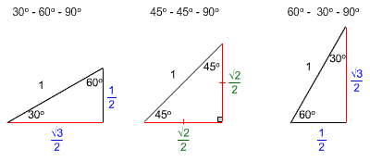
Degrees | Radians | Degrees | Radians
$$\sin{30}=\frac{1}{2}$$ | $$\sin{\frac{π}{6}}= \frac{1}{2}$$ | $$\cos{30= \frac{\sqrt{3}}{2}}$$ | $$\cos{\frac{π}{6}}= \frac{\sqrt{3}}{2}$$
$$\sin{45}=\frac{\sqrt{2}}{2}$$ | $$\sin{\frac{π}{4}}= \frac{\sqrt{2}}{2}$$ | $$\cos{45}=\frac{\sqrt{2}}{2}$$ | $$\cos{\frac{π}{4}}=\frac{\sqrt{2}}{2}$$
$$\sin{60}=\frac{\sqrt{3}}{2}$$ | $\sin{\frac{π}{3}}$ = $\frac{\sqrt{3}}{2}$ | $$\cos{60}=\frac{1}{2}$$ | $$\cos{\frac{π}{3}}=\frac{1}{2}$$

