Pentagons

**Base: 4.5 cm Height: 3.44 cm**

**Number of pentagons on a soccer ball:**

**Number of triangles:**

**Area of each triangle: $\frac{1}{2}*base*height$**

**Area of each triangle * Number of triangles * Number of pentagons = Area from Pentagons**

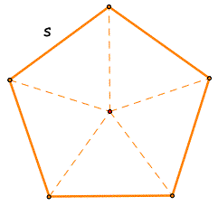

Hexagons

**Base: 4.5 cm Height: 2.25 cm**

**Number of hexagons on a soccer ball:**

**Number of triangles:**

**Area of each triangle: $\frac{1}{2}*base*height$**

**Area of each triangle * Number of triangles * Number of Hexagons = Area from Hexagons**

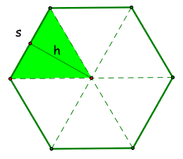

Approximate Area (Hexagons + Pentagons)

Actual Surface Area (SA = 4πr2) r =