Pentagons

**Base: 4.5 cm Height: 3.44 cm**

**Number of pentagons on a soccer ball: 12**

**Number of triangles: 5**

**Area of each triangle: $\frac{1}{2}*base*height$**

**.5(4.5)(3.44) = 7.74 cm2**

**Area of each triangle * Number of triangles * Number of pentagons = Area from Pentagons**

**7.74 *5*12 = 464.4 cm2**

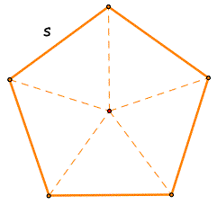

Hexagons

**Base: 4.5 cm Height: 3.9 cm**

**Number of hexagons on a soccer ball: 20**

**Number of triangles: 6**

**Area of each triangle: $\frac{1}{2}*base*height$**

**.5 (4.5)(3.9) = 8.775 cm2**

**Area of each triangle * Number of triangles * Number of Hexagons = Area from Hexagons**

**8.775 * 6 * 20 = 1053cm2**

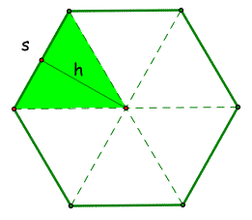

Approximate Area (Hexagons + Pentagons)

1517.4cm2

Actual Surface Area (SA = 4πr2) r = 10.98 (69)

1515.47cm2