The Fundamental Theorem of Arithmetic

Arithmetic: the branch of mathematics dealing with the properties and manipulation of numbers.

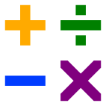

Algebra: the part of mathematics in which letters and other general symbols are used to represent numbers and quantities in formulae and equations.

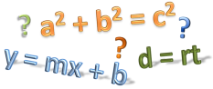

Factors

Factors are numbers which can be multiplied together to obtain a product.

Some numbers have many factors, some have only one set.

**It can be two or more numbers. 2 * 2 * 2 * 3 = 24 as well**

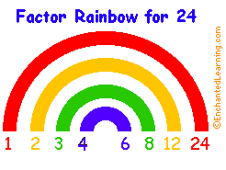

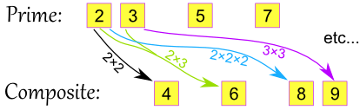

**Prime Number**

**A prime number is a whole number greater than 1, whose only two whole-number factors are 1 and itself. As we proceed in the set of natural numbers N = {1, 2, 3, ...}, the primes become less and less frequent in general.**

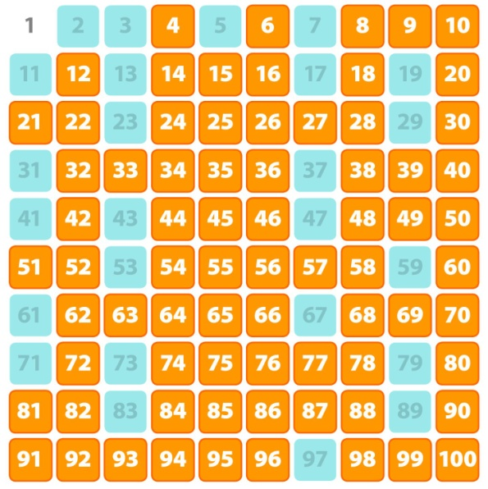

Prime Factorization

A process by which any number is broken down into a set of unique prime factors.

**Composite Numbers**

**A whole number that can be divided evenly by numbers other than 1 or itself.**

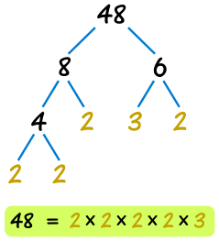

The Fundamental Theorem of Arithmetic

Any whole number greater than one is either prime or the product of a unique set of prime numbers.