**Identify each pair of angles as adjacent, vertical, complementary, supplementary, or a**

**linear pair.**

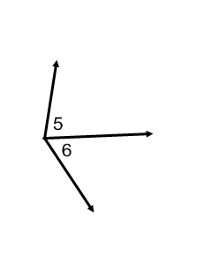

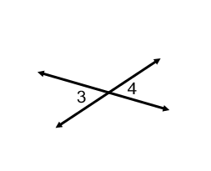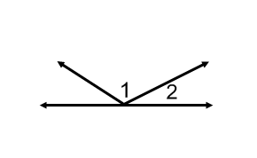**1. 2. 3.**

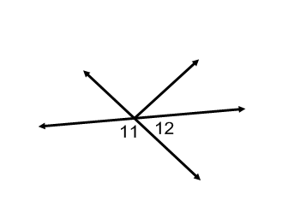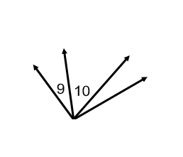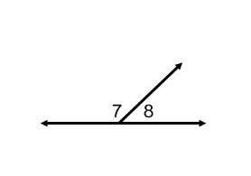

**4. 5. 6.**

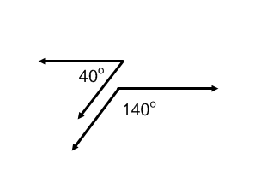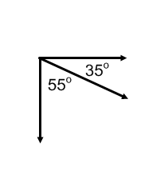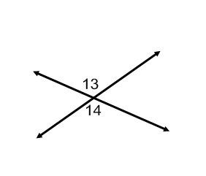

**7. 8. 9.**

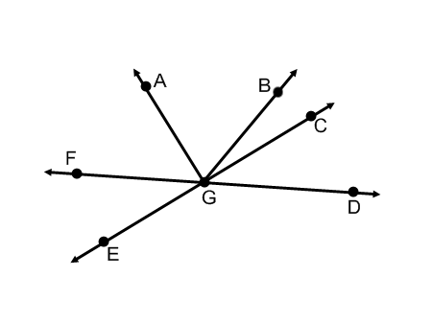**Use the figure at the right to answer each question.**

1. Name two acute vertical angles.
2. Name two obtuse vertical angles.
3. Name a pair of adjacent angles
4. Name a linear pair.
5. Name a pair of complementary angles.
6. Name an angle supplementary to 



**For #1-6, use the figure at the right.**

1. Name two acute vertical angles.
2. Name two obtuse vertical angles.
3. Name a linear pair.
4. Name two acute adjacent angles.
5. Name an angle complementary to .
6. Name an angle supplementary to .

**Find the measure of each numbered angle.**

**7. 8. 9.**

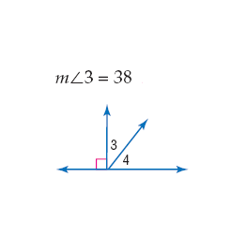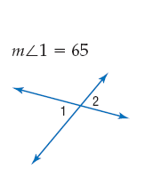

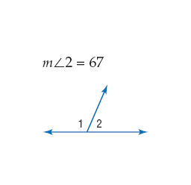**10. 11. 12.**



**13. 14. 15.**

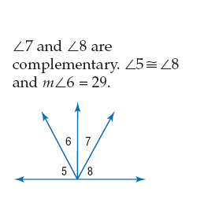

**16. 17. 18.**