**Working with Proportions**

**Equivalent Fractions**

Two fractions are said to be equivalent if they can represent the same ratio with different numbers.

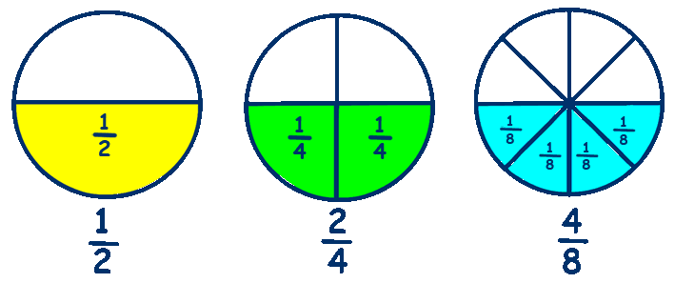

$$\frac{20}{x}=\frac{5}{7}$$

$$5x=20*7$$

$$5x=140$$

$$\frac{5x}{5}=\frac{140}{5}$$

$$x=28$$

Yes my answer makes sense, 5 * 4 makes 20 and 7 * 4 makes 28.

**-OR-**

$$\frac{20}{28}=\frac{5}{7}$$

$$140=140$$

$$\frac{3}{9}=\frac{1}{3}\underset{→}{yields}\frac{3}{1}=\frac{9}{3}$$

$$\frac{8}{16}=\frac{5}{10}\underset{→}{yields}\frac{8}{5}=\frac{16}{10}$$

**Rearranging Fractions**

Equivalent Fractions can be written

$$\frac{a}{b}=\frac{c}{d}\underset{→}{yields}\frac{a}{c}=\frac{b}{d}$$

$$Are \frac{6}{8}and\frac{9}{12} proportional?$$

$$\frac{6}{8}=\frac{3*2}{4*2}=\frac{3}{4} \frac{9}{12}=\frac{3*3}{4*3}=\frac{3}{4}$$

$$\frac{6}{8}=\frac{9}{12}$$

**8 * 9 = 6 *12**

**72 = 72**

**Testing for Proportionality**

**Method #1: Reduce both fractions to simplest form.**

**Method #2: Cross multiply**

1. **Multiply bottom left with top right.**
2. **Multiply top left with bottom right.**
3. **If the resulting numbers are equal, the fractions are proportional.**

**Proportional**

Two fractions which are equivalent are also said to be proportional.

Proportional means that there is a constant ratio between fractions

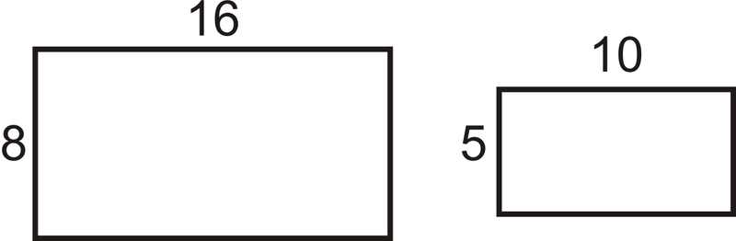

Solving for Unknown Values

Like any equations, we can solve for unknown values with proportions because there is an equal sign.

We know two fractions are proportional when there is an equal sign.

For most people, cross multiplication works best. Use the method used in testing for proportionality.

1. **Set both fractions equal to one another.**
2. **Multiply the bottom left and top right and rewrite below.**
3. **Multiply the top left and bottom right and rewrite below**
4. **Divide by the coefficient to solve.**
5. **Check/Does my answer make sense?**